MATLAB Assignment # 1

By: Jonathan Lopez

ECE 2010

Section B03



Due 11/3 9PM

MATLAB PROBLEM 2 ECE2010 B19

Working with MATLAB Scripts
Due Submission Online– Sunday Nov. 3rd by 9:00 PM

Preamble
In our second MATLAB assignment, we will learn how to
- Use a MATLAB script instead of the Command Window. Writing a script (or a number of them) is more beneficial for realistic engineering tasks;
- Use a for loop in MATLAB;
- Use matrices (2D arrays) in MATLAB;
- Use 2D contour plots in MATLAB.
We will also investigate some basic operations with solar electric power (distributed power, total power).
Your Task #1
- Create a new MATLAB script (use commands New->Script or Ctrl+N at the top left of the MATLAB Command window). The MATLAB script is a program written in MATLAB language. Save your script as script01.m
- Edit the script: copy and paste into the script the following statements (do not forget to remove the previous one), and determine which of them will correctly execute by running, and provide the result and its short description. If the command does not correctly execute, state why.
- You can execute the MATLAB script in three different ways: by clicking (Run), by using right mouse click on the script name (and select run option) in the Current Folder Window, or just by typing the script name in the Command Window and hitting ENTER. The script execution result appears in MATLAB Command Window.

a.
clear; clc
for m = 1:3
string = string + 'ECE2010 ';
disp(string);
end
b.
clear; clc
M = [1 2 8];
for m = M
value = m^2;
disp(value);
end
c.
clear; clc
N = 5; A = zeros(1, N+1);
for m = 1:N+1
A(m) = acosd((m-1)/N^2);
end
A
d.
clear; clc
N = 5; A = zeros(1, N+1);
for m = 1:N+1
A(m) = sinh((m)/N^2);
end
A
% Now, consider an equivalent (vectorized!) statement:
argument = [1:1:6]/N^2;
A = sinh(argument)
e.
clear;
t = 0:pi/10:2*pi;
for m = 1:12
[X,Y,Z] = cylinder(2-sin(t), m);
surf(X,Y,Z); axis square;
drawnow; pause(0.5)
end

Your report should include the script execution result and a short explanation.

a. | clear; clc  for m = 1:3  string = string + 'ECE2010 ';  disp(string);  end  ECE2010  ECE2010 ECE2010  ECE2010 ECE2010 ECE2010  This script runs for m = 1 through 3 and adds the string of text ECE2010 for every next line it goes to ex line 1 gets 1 ECE2020 line 2 gets ECE2010 ECE2010ss etc.
b. | clear; clc  M = [1 2 8];  for m = M  value = m^2;  disp(value);  end  1  4  64  This script takes the numbers in the array and squares them and spits out their new value
c. | clear; clc  N = 5; A = zeros(1, N+1);  for m = 1:N+1  A(m) = acosd((m-1)/N^2);  end  A  A =  90.0000 87.7076 85.4114 83.1079 80.7931 78.4630  This script takes 6 values and puts in the function inverse cosine m-1/N^2 and it runs for m =1 and N+1 every time it runs through until N=5. Zeros has an array of N+1 so 6 numbers
d. | clear; clc  N = 5; A = zeros(1, N+1);  for m = 1:N+1  A(m) = sinh((m)/N^2);  end  A  A =  0.0400 0.0801 0.1203 0.1607 0.2013 0.2423  This script does almost the same of the last one but takes the sine of the values (m/N^2) this would be the hyperbolic sine function
e. | clear;  t = 0:pi/10:2*pi;  for m = 1:12  [X,Y,Z] = cylinder(2-sin(t), m);  surf(X,Y,Z); axis square;  drawnow; pause(0.5)  end  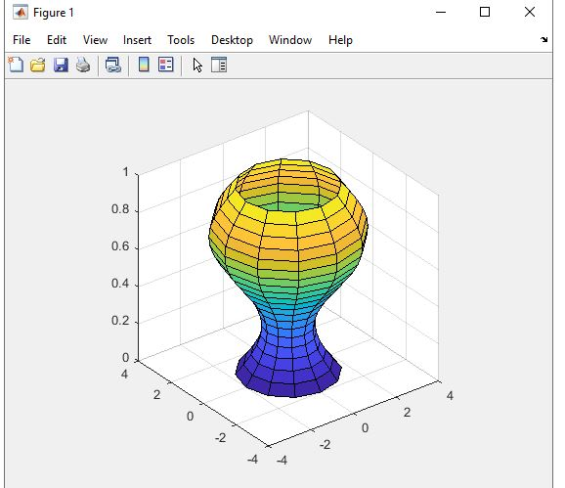  This script draws the side of a cylinder with and curves inwards. It takes that and make it 3d and increasing the resolution every time running from m=1 to 12. Pausing eveyr ½ second until its at it’s final form

Additionally, please answer the following questions (for example, you could type help clc and hit ENTER in the MATLAB Command Window or do Help search, e.g. comment operators):

What is the function of command clc ? | Clear Command window
What is the function of operator %? | comments
What is the function of command clear? | Clear variables stored
What is the purpose of function disp? | Disp means to display in the command windows

Your Task #2

Part A. Write and test a short MATLAB script that clears the workspace, then computes and displays in the Command Window the values of a function $\ln\left(x\right)$. The argument, $x$, covers the interval from 0 to 6 in ten discrete uniform steps. Present the text of your code and the output result. You may use a loop or vectorize you code. Hint: to create the argument array, you could use a handy MATLAB function linspace (type help linspace to understand its operation).

clear; clc
M = [0 1 2 3 4 5 6];
for m = M
value = log(m);
disp(value);
end
results
-Inf

0

0.6931

1.0986

1.3863

1.6094

1.7918

Part B. Write and test a short MATLAB script that clears the workspace, then computes and displays in the Command Window the value of an integral $I=\int_{0}^{1}{e^{\frac{1}{2}x^{2}}dx}$. Use the midpoint integration rule:
$$\int_{a}^{b}{f(x)dx}= ∆x\sum_{n=1}^{N}{f(x_{n})}$$
where array $x_{n}$ may be constructed as

X = linspace(a, b, N+1);
xn = 1/2*(X(2:end)+X(1:end-1));

Present the text of your code and the output result with 5 significant digits for $N=100$.

clear; clc
lower=0;
upper=1;
N=10;
deltax=(upper-lower)/N;
x=[lower:deltax:upper];
f = @(x) (exp((1/2)*x.^2));
mpr=0;
for k=1:N;
mpr=mpr+f((2*k+1)/2)*deltax;

end;

fprintf('%f.\n',mpr);

Midpoint approximation = 87197299258982213353472.000000.

Your Task #3

Problem statement
To date, the average electricity consumption of the USA is approximately 5×10¹¹ W=500 Gigawatts. A beginner electrical engineer estimates the size of a square area in the state of Arizona to be covered with c-Si solar cells or with a-Si solar cells in order to fulfill this need.

The engineer intends to check all possible square areas from 1×1 to 150×150 miles, as well as all possible panel efficiencies from 1 to 20%. After that he/she would like to create a contour plot in order to observe how the required area increases/decreases depending on the available efficiency.

An older colleague from the same company has already started a MATLAB script for that purpose, which is given below. However, this colleague made four programming mistakes:

clear;
close all;
%--------------------------------------------------------
% Vector of available area widths (a 1D array of numbers)
Wmiles = [1:1:150]; % width of the square area in miles (vector or 1D array)
Wmeters = Wmiles*1609; % width of the square area in meters (vector or 1D array)
A = Wmeters*Wmeters; % area in m^2 (vector or 1D array); need element-by-element
% vector multiplication!
%--------------------------------------------------------
% Vector of available array efficiencies (a 1D array of numbers)
E = [1:1:20]; % efficiency percentage (vector or 1D array)
%--------------------------------------------------------
% Matrix of all available total output powers of the array (a 2D array of numbers)
p = 270.9; % average daily solar radiation in W per m^2 (scalar)
for i = 1,length(A) % index i corresponds to different areas A
for j = 1,length(A) % index j corresponds to different efficiencies E
P(i,j) = p*A(i)*E(j)*0.01; %total average daily power (2D matrix)
end
end
%--------------------------------------------------------
% "Plot" the matrix - a contour plot of all available total output powers
v = [2 10 50 100 300 500 1000]; % create contour plot levels in GWatts
C = contourf(P*1e-9, v); % create contour plot of output powers in GWatts
colormap(summer);
clabel(C, 'FontSize', 12, 'Color', 'r'); % be fancy (do not have to!)
xlabel('This is the x-axis'); ylabel('This is the y-axis');

How to solve the task:

- Create an empty MATLAB script, then copy and paste the above text there. Save the script. Give your own script name (do not use blank spaces). Note that all comments are marked green.

- Run the script. You will see error message(s), one by one, in the MATLAB Command Window.

- Find, highlight and fix all bugs in the above script. Remember: all programming errors are reported in red in MATLAB Command Window. Example: 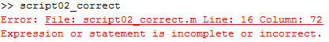
You could click on the error message; it will bring you to the line it was unable to execute because of the error (this may not be the actual location of the error!).

- Properly label figure axes, insert the grid, and insert the figure title. The x-axis should be “Solar panel efficiency percentage, E”; the y-axis should be the “Width of the square area in miles”, the title should be “Output power in Gigawatts”.

- Include the list of errors with fixes and the final contour plot into your MATLAB report.

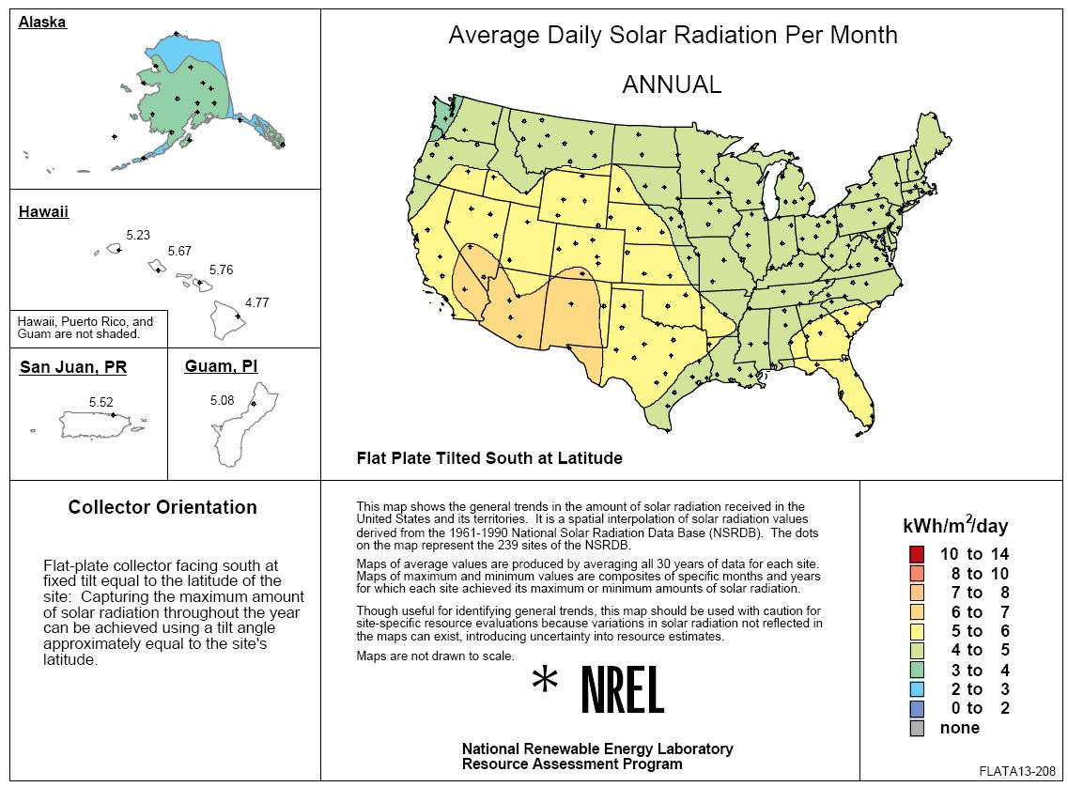

Fig. 1. A map of average daily solar radiation from National Renewable Energy Laboratory, U.S.

Error #1 | They forgot a period right before the multiplication sign rewrite as the matrix squared
Error #2 | For the j function replace A with E
Error #3 | Replace the comma in the first For loop with a colon (:) to do the range of i from 1 to length(E).
Error #4 | Replace the comma in the second For loop with a colon (:) to do the range of j from 1 to length(A).
Contour plot:
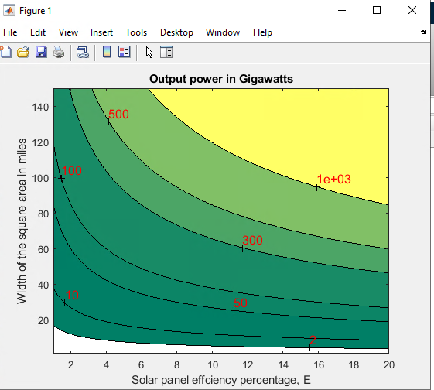

Question
Based on your contour plot, please answer the following question: what is the minimum possible square area (and its width in miles) that gives us the average electric output of the array greater than or equal to the current USA electric consumption of 5×10¹¹ W=500 Gigawatts at the solar panel efficiency of 15%? Hint: you could use the data cursor function of the figure menu to identify the proper point.

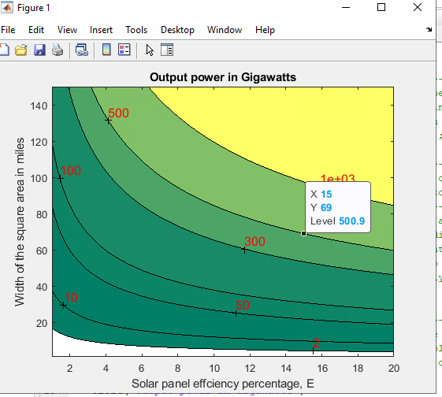
The minimum possible square area is 4791 miles^2 and the width would be 69 miles. This would get you to an output power of 500 GW at 15% solar panel efficiency.

